

Unveiling Shared Molecular Pathways Between COVID-19 and Alzheimer’s Disease
Final report

Names ID
Malak Reda 231001933
Abdallah Mohamed 231002006
Sama saeed 221002117
Haneen Mohamed 221000582

CBIO311 / CBIO310
Dr. Mohamed EL-Sayeh

January,2026

Abstract:
COVID-19, caused by the SARS-CoV-2 virus, and Alzheimer's disease (AD), a progressive neurodegenerative disorder, share overlapping biological mechanisms such as inflammation, oxidative stress, and mitochondrial dysfunction. This study explores these connections through gene expression analysis using publicly available datasets for both diseases. Differentially expressed genes (DEGs) were identified and subjected to Gene Set Enrichment Analysis (GSEA) to pinpoint enriched pathways. Results highlight critical pathways such as oxidative phosphorylation, neurodegenerative processes (e.g., Alzheimer’s and Parkinson’s diseases), and cellular stress pathways like endocytosis and ubiquitin-mediated proteolysis. These findings suggest shared pathophysiology between COVID-19 and AD, providing insights into the molecular mechanisms that link viral infections to neurodegeneration.

Introduction:
COVID-19:
COVID-19 (Coronavirus Disease 2019) is a contagious disease caused by the SARSCoV-2 virus. It primarily affects the respiratory system but can lead to systemic complications, including inflammation, multi-organ damage, and neurological effects. Symptoms range from mild (fever, cough) to severe (pneumonia, respiratory failure).
Alzheimer’s Disease:
Alzheimer’s disease (AD) is a progressive neurodegenerative disorder and the most common cause of dementia. It is characterized by memory loss, cognitive decline, and behavioral changes. It results from the buildup of amyloid plaques and tau tangles in the brain, leading to neuronal damage and brain atrophy.
COVID-19 and Alzheimer's Disease: A Brief Overview
COVID-19, caused by SARS-CoV-2, has been linked to neurological complications, including memory loss and cognitive decline. These effects may overlap with processes involved in Alzheimer’s disease (AD).
- Shared Mechanisms:
- Inflammation: COVID-19 triggers systemic inflammation (cytokine storm), which can exacerbate neuroinflammation, a key driver of Alzheimer’s progression.
- Oxidative Stress: Increased oxidative damage from COVID-19 impacts brain cells and may accelerate neurodegeneration.
- Mitochondrial Dysfunction:
- Both conditions involve mitochondrial impairment, reducing energy production and increasing cell damage, especially in neurons.
- Long-Term Risks:
- Severe COVID-19 may elevate the risk of developing Alzheimer's-like symptoms, particularly in older adults or those with pre-existing vulnerabilities.
Methodology:
This study utilized two publicly available gene expression datasets: GSE164332 for COVID-19 and GSE122063 for Alzheimer’s disease. Raw data from these datasets were processed to generate Differentially Expressed Genes (DEGs) tables. Each table was standardized by renaming key columns, such as gene identifiers and fold change values, to ensure consistency. The tables were then merged by gene identifiers to facilitate comparative analysis. DEGs were filtered based on two criteria: a log2 fold change threshold of ±1.1 and an adjusted p-value (padj) of less than 0.05. These thresholds were used to identify significantly upregulated and downregulated genes, which were saved in separate tables for downstream analysis.
Additionally, a combined table of all filtered DEGs was created for comprehensive exploration.
To visualize gene expression changes, a volcano plot was generated, categorizing genes as "Upregulated," "Downregulated," or "Neutral" based on the applied thresholds. A heatmap of log2 fold changes was also created, providing a visual representation of expression patterns across selected genes. Both visualizations served to highlight significant trends in the data.
Gene Set Enrichment Analysis (GSEA) was performed on the filtered upregulated and downregulated genes using the KEGG pathway database for Homo sapiens (hsa). This analysis was implemented in R with the cluster Profiler package. Enrichment was assessed with parameters including a minimum gene set size of 3, a maximum gene set size of 800, and a pvalue cutoff of 0.05. To ensure robust interpretation, the gene lists were ranked and sorted by their log2 fold changes in descending order, and NA values were omitted. Results from the enrichment analysis identified key biological pathways significantly impacted Alzheimer’s disease and COVID-19.
Various plots were generated to visualize the enrichment results, including dot plots for the top 10 enriched pathways, enrichment maps for pathway similarity, category network plots to illustrate relationships between genes and pathways, and ridge plots to display enrichment score distributions. Additionally, specific KEGG pathways were visualized using the pathview package, mapping the expression data onto pathway diagrams for better biological context. All enrichment results and pathway descriptions were exported to CSV files for further interpretation and documentation.
The analysis was implemented using R due to its robust libraries and tools for bioinformatics workflows. Key packages included dplyr for data manipulation, ggplot2 for visualization, pheatmap for heatmap creation, clusterProfiler for enrichment analysis, and pathview for KEGG pathway visualization. Results were saved in multiple formats using the openxlsx package to ensure accessibility and reproducibility. Overall, this methodology combined data preprocessing, DEG filtering, enrichment analysis, and visualization to provide a comprehensive exploration of gene expression and pathway involvement in Alzheimer’s disease and COVID-19.

Results:
This study highlights the shared molecular mechanisms between COVID-19 and Alzheimer’s disease (AD) through a focused analysis of differentially expressed genes (DEGs). The findings from the most significantly upregulated and downregulated genes reveal critical pathways that provide insights into their potential biological and clinical implications.
1. Upregulated Genes
- NFE2L1: This gene, encoding the NFE2-like bZIP transcription factor 1, plays a critical role in cellular oxidative stress responses. Its upregulation may reflect an adaptive mechanism to counteract the oxidative damage observed in both COVID-19 and neurodegenerative diseases such as AD. NFE2L1's involvement in the regulation of proteasomal degradation pathways aligns with findings of dysregulated protein turnover in both conditions.
- BACH1: A transcription factor involved in antioxidant defense, BACH1 has been implicated in mitigating oxidative damage. Its upregulation suggests an activated response to systemic oxidative stress induced by SARS-CoV-2 infection and neuroinflammation seen in AD.
- *PDP2*: Pyruvate dehydrogenase phosphatase catalytic subunit 2 is associated with mitochondrial energy metabolism. The observed upregulation of PDP2 highlights mitochondrial dysfunction as a shared hallmark between the two conditions.
2. Downregulated Genes
- PHPT1: Phosphohistidine phosphatase 1’s downregulation suggests potential disruptions in intracellular signaling cascades critical for neuronal survival and repair mechanisms.
- INTS3: This gene’s involvement in DNA damage repair pathways makes its downregulation noteworthy, as it could exacerbate cellular stress and neurodegeneration associated with both diseases.
The enriched pathways linked to these DEGs underscore the interplay between systemic inflammation, oxidative stress, and mitochondrial dysfunction in COVID-19 and AD:

- Oxidative Stress: The upregulation of genes like NFE2L1 and BACH1 indicates an adaptive antioxidant response. However, the chronic nature of oxidative stress in both conditions may overwhelm these protective mechanisms, contributing to neuronal damage.
- Mitochondrial Dysfunction: Downregulation of mitochondrial-associated genes such as PHPT1 reflects impaired energy production and increased vulnerability to neurodegeneration.
- Protein Degradation: Dysregulated ubiquitin-mediated proteolysis, as highlighted in the pathway analysis, aligns with the shared pathology of protein aggregation in AD and cellular damage in COVID19.
These findings have significant therapeutic implications:
1-Targeting Oxidative Stress: Enhancing antioxidant pathways through pharmacological agents may mitigate the damaging effects of oxidative stress in patients with severe COVID-19 or those at risk of AD.
2-Mitochondrial Function: Interventions aimed at restoring mitochondrial health, such as NAD+ boosters or mitochondrial antioxidants, could be beneficial in alleviating symptoms of both diseases.
3-Protein Homeostasis: Strategies to modulate the ubiquitin-proteasome system might reduce the pathological accumulation of proteins characteristic of AD and cellular damage in COVID-19.
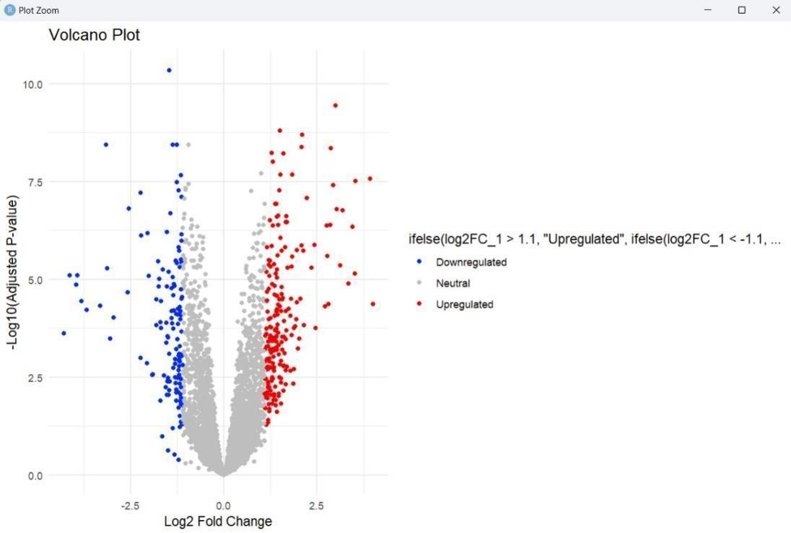
This is a *volcano plot*, a common visualization in RNA-seq data analysis used to highlight differentially expressed genes (DEGs). It shows the relationship between the magnitude of change (fold change) and the significance of that change (p-value).
Result:
Upregulated Genes (Red):
o These genes are significantly expressed in the condition of interest (test group). o Higher log2FC and -log10(p-value) suggest strong differential expressions.
Downregulated Genes (Blue):
- These genes are significantly less expressed in the condition of interest.
- Similarly, strong changes are further to the left and high on the Yaxis. o Neutral Genes (Gray):
- These genes do not show statistically significant differential expression or fall within the threshold limits.
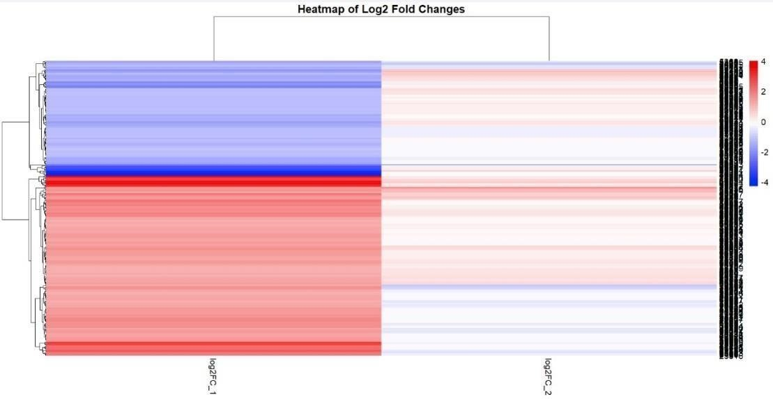
The purpose of this heatmap is to identify and visualize differences in gene expression between COVID-19 and Alzheimer's disease.
It helps in:
- Discover Biomarkers: Find specific genes or patterns linked to each condition.
- Understand Disease -Mechanisms: Explore shared or unique biological pathways affected by COVID-19 and Alzheimer’s. o Guide Therapy Development: Identify potential targets for treatment or interventions tailored to either or both diseases.
Results:
This heatmap shows gene expression differences (Log2 fold changes) between COVID-19 and Alzheimer’s. Red indicates genes that are more active (upregulated), while blue indicates genes that are less active (downregulated). The results highlight distinct gene expression patterns, suggesting unique and shared biological pathways between the two conditions, which could help identify potential biomarkers or therapeutic targets.
Pathway Enrichment Analysis for Upregulated Genes
Several important pathways linked to cellular functions and illnesses were identified by the Gene Set Enrichment Analysis (GSEA) of upregulated genes. Notably, important pathways included the Hippo Signaling Pathway, Toxoplasmosis, and Basal Cell Carcinoma. These pathways emphasize infection responses, tumorigenesis, and the control of cellular growth. Important roles in intracellular transport and pigmentation processes are suggested by other enriched pathways, such as endocytosis and melanogenesis. A hallmark of programmed cell death, the apoptosis pathway highlights the effects of cellular stress and damage. Signaling-Regulated Pluripotency of Stem Cells and Pathogenic Escherichia coli Infection Pathways point to links between immune responses and the determination of cell fate.
Pathway Enrichment Analysis for Downregulated Genes
For the downregulated genes, GSEA identified pathways primarily involved in neurological and metabolic functions. Significant pathways included Oxidative Phosphorylation, Parkinson’s Disease, and Alzheimer’s Disease, all linked to mitochondrial dysfunction and neurodegeneration. Other critical pathways such as Prion Disease, Huntington Disease, and Amyotrophic Lateral Sclerosis reinforce the association between protein misfolding, neuronal death, and impaired cognitive functions. Metabolic dysregulation was highlighted by pathways like Diabetic Cardiomyopathy and Thermogenesis, while Chemical Carcinogenesis - Reactive Oxygen Species and Ubiquitin-Mediated Proteolysis underscore the role of oxidative stress and protein degradation in disease progression.
Interrelation Between COVID-19 and Alzheimer’s Disease
The pathway analysis demonstrates significant overlaps between COVID-19 and Alzheimer’s disease in terms of impacted biological processes. COVID-19’s systemic inflammation and oxidative stress, as reflected in pathways like Oxidative Phosphorylation and Chemical Carcinogenesis, parallel the neuroinflammatory and oxidative damage mechanisms underlying
Alzheimer’s. Pathways such as Apoptosis and Neurodegeneration provide additional links, as COVID-19’s inflammatory cytokine storm can exacerbate neuronal damage, potentially accelerating Alzheimer’s progression in affected patients.
Furthermore, pathways like Basal Cell Carcinoma and Hippo Signaling suggest disruptions in cellular repair and growth, which may interact with Alzheimer’s hallmark features of cell death and degeneration. The enrichment of Endocytosis and Ubiquitin-Mediated Proteolysis pathways indicates a shared impairment in cellular machinery for clearing misfolded proteins and cellular debris, a critical issue in both diseases.
Shared Pathway Implications
These results demonstrate the biological link between COVID-19 and Alzheimer's disease, indicating that COVID-19 infection may serve as a trigger for the development or advancement of neurodegenerative diseases. The common pathways highlight how crucial it is to address oxidative, metabolic, and inflammatory dysfunctions in treatment plans to lessen the effects of both illnesses. To understand the underlying molecular mechanisms connecting these different but related conditions, more research is necessary considering this correlation.
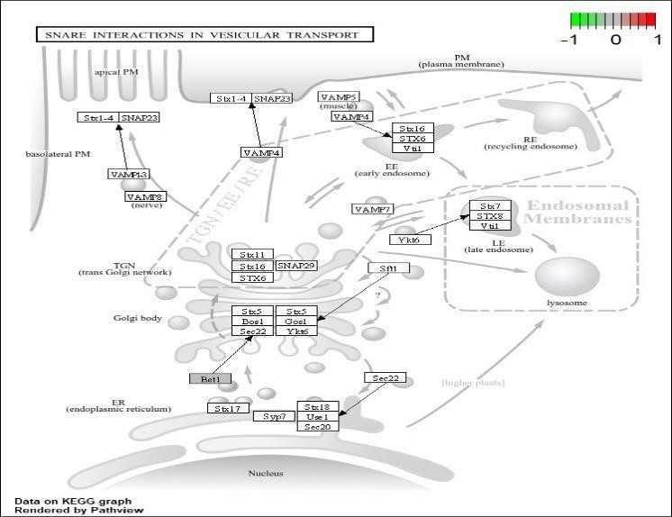
Baseline Pathway Map What
it Represents:
This is a standard KEGG pathway map showing the components of the SNARE-mediated vesicular transport system.
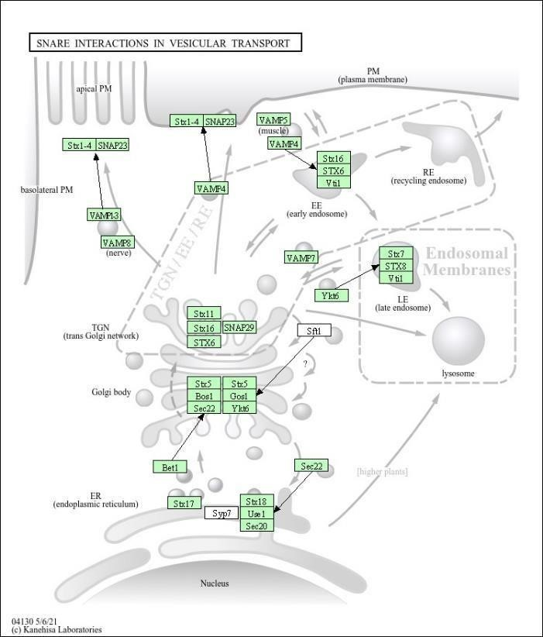

Experimental Overlay on Pathway Map What
it Represents:
This is the same pathway map, but it includes experimental data mapped onto it.
Color Coding:
Red: Upregulated genes/proteins in the dataset.
Green: Downregulated genes/proteins.
White: Proteins with no significant changes in expression.
Gradient Bar (-1 to 1): Indicates the intensity of regulation, with -1 being strongly downregulated and 1 being strongly upregulated.

SNARE interactions in vesicular transport ensure the specificity and efficiency of intracellular trafficking, playing a central role in maintaining cellular function. Dysregulation of SNAREmediated processes can lead to a range of disorders, including viral infections (e.g., COVID-19) and neurodegenerative diseases (e.g., Alzheimer’s). Understanding this pathway is essential for developing therapeutic strategies targeting vesicle transport disruptions.
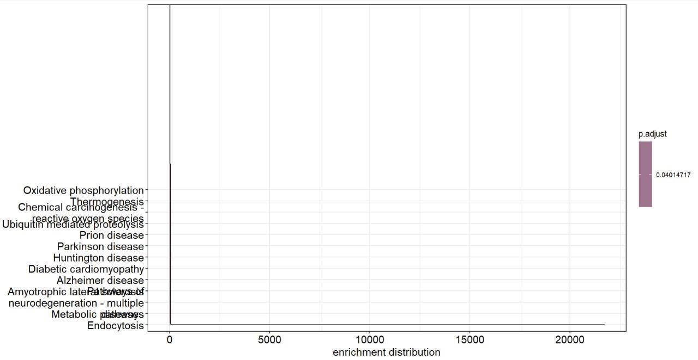
The results likely indicate that certain pathways (e.g., oxidative phosphorylation, neurodegeneration-related pathways) are significantly enriched in the dataset you analyzed. This suggests a biological link, such as the impact of COVID-19 on pathways relevant to Alzheimer’s disease and other neurodegenerative conditions.
Key Insights from the Graph:
- Pathways Listed on the Y-Axis:
  - These are biological processes or disease-related pathways, such as oxidative phosphorylation, Alzheimer’s disease, and Parkinson’s disease. o
These pathways may be overrepresented or significantly enriched in the gene set or data analyzed.
- Enrichment Distribution (X-Axis):
  - The x-axis shows the enrichment distribution, which likely reflects how strongly each pathway is associated with the input data. o Longer bars indicate higher enrichment, meaning that a larger proportion of the input genes (or data) are involved in that pathway.
- Color Bar (p.adjust):
  - The color gradient represents the adjusted p-value (p.adjust), which corrects multiple comparisons to identify statistically significant pathways.
  - All the pathways in the graph seem to have a p.adjust value of ~0.0401, meaning they are marginally significant.
- Biological Relevance:
    - The pathways listed are highly relevant to neurodegeneration and cellular energy processes, which are associated with both COVID-19 and Alzheimer’s disease. For example: o Oxidative phosphorylation: Central to cellular energy production; dysfunction is linked to neurodegeneration and oxidative stress.
    - Reactive oxygen species (ROS): Implicated in oxidative damage and inflammation, which are features of both Alzheimer’s disease and severe COVID-19.
    - Alzheimer’s disease: Suggests a direct enrichment of genes/pathways involved in neurodegeneration, which could be affected by COVID19related inflammation or hypoxia.
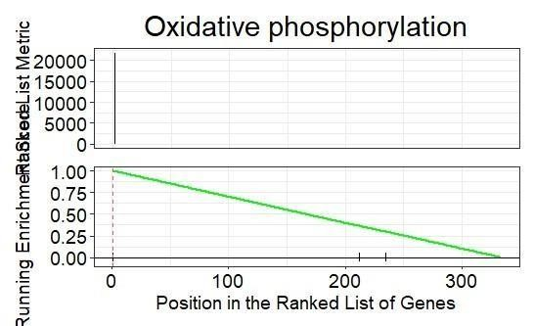
The graph represents the results of a Gene Set Enrichment Analysis (GSEA) for the oxidative phosphorylation pathway. It shows how genes from this pathway are distributed and enriched in the ranked gene list of your dataset.
Key Elements of the Graph:
- Top Panel (Ranked List Metric):
  - Indicates the distribution of genes based on their ranking in the dataset, usually by differential expression or some scoring metric.
- Bottom Panel (Running Enrichment Score):
  - The green line represents the cumulative enrichment score (ES) across the ranked gene list.
  - A sharp decline indicates that most of the genes in the pathway are concentrated at the top of the ranked list, meaning they are highly relevant in the context analyzed.
- Vertical Tick Marks:
  - Represent the positions of genes belonging to the oxidative phosphorylation pathway in the ranked list.
- Pathway Enrichment:
  - The analysis suggests that the oxidative phosphorylation pathway is positively enriched, meaning it plays a significant role in the observed biological condition.
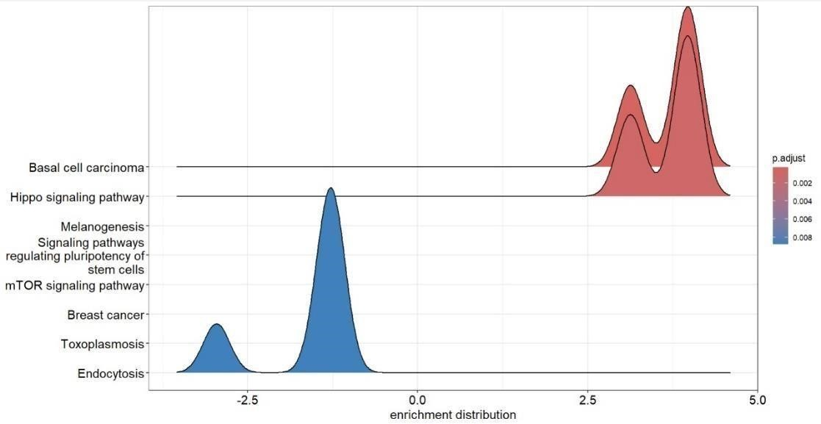
This graph is likely a result of enrichment analysis (e.g., Gene Set Enrichment Analysis or pathway enrichment analysis) performed on RNA-Seq data to identify significant pathways related to differential gene expression in a case-control study.
- Pathways on the Y-axis:
o Each label (e.g., "Basal cell carcinoma," "Hippo signaling pathway") represents a pathway or biological process that is significantly enriched based on the analysis. o These pathways likely represent gene sets showing differential expressions between the two conditions.
- Enrichment Distribution on the X-axis:
  - This axis represents the enrichment score, which quantifies how much the
pathway is overrepresented in the dataset. o Positive values suggest overrepresentation of genes associated with the pathway in
one condition, while negative values indicate enrichment in the other condition.
3-Colored Peaks:
  - The density distribution (peaks) visualizes how the enrichment scores are distributed for the genes in each pathway. o Red and blue colors represent pathways with varying adjusted pvalues
(p.adjust), indicating the statistical significance of the enrichment:
  - Red Peaks: Higher significance (smaller p.adjust values). o
Blue Peaks: Lower significance (larger p.adjust values).
4-Statistical Significance: Pathways with smaller p.adjust values (darker red) are more statistically significant, meaning their enrichment is less likely to occur by chance.
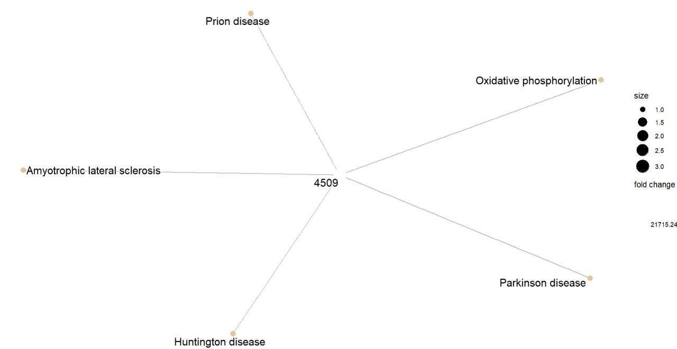
Key Elements of the Graph:
- Central Node (4509): This likely indicates a count of significant genes or transcripts that were differentially expressed in the study.
- Surrounding Nodes: Each node represents a specific disease or biological process:
o Prion Disease o Amyotrophic Lateral
Sclerosis (ALS) o Huntington Disease o Parkinson
Disease o Oxidative
Phosphorylation
- Node Size: The size of each node may reflect the number of significant genes associated with that particular disease or process. Larger nodes represent more genes.
- Fold Change: The graph may also indicate the magnitude of change in gene expression (fold change) associated with each disease. This helps in understanding how significantly gene expression differs in the context of COVID-19 versus Alzheimer's.
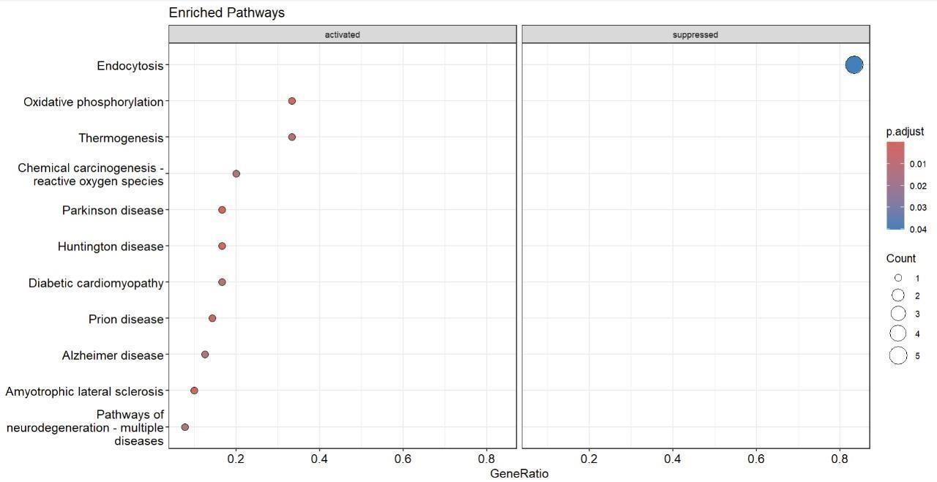

The graph highlights key biological pathways that are either activated or suppressed in the context of the diseases being studied.
Key Elements of the Graph:
- Axes:
  - X-Axis (Gene Ratio): This indicates the proportion of genes associated with each pathway relative to the total number of genes analyzed. A higher gene ratio suggests a stronger association between the pathway and the conditions studied. o Y-Axis: Lists the enriched pathways, with pathways on the left indicating activation and those on the right indicating suppression.
- Points:
  - Each point represents a specific pathway or disease.
The size of the point (Count) reflects the number of genes involved in that pathway. Larger points indicate more genes.
o The color of the points is determined by the p-value (p.adjust), where darker
colors signify more statistically significant results.
Pathways:
- Activated Pathways (Left Side):
o Endocytosis: Indicates a significant activation in gene expression related to this pathway. o Oxidative Phosphorylation: Another pathway that shows activation, suggesting its potential role in the studied conditions.
- Suppressed Pathways (Right Side):
Thermogenesis
o Chemical Carcinogenesis – Reactive Oxygen Species o Parkinson Disease o Diabetic Cardiomyopathy o Huntington Disease o Alzheimer Disease o prion disease o Amyotrophic Lateral Sclerosis
These pathways show suppression, indicating a decrease in gene expression associated with these conditions.

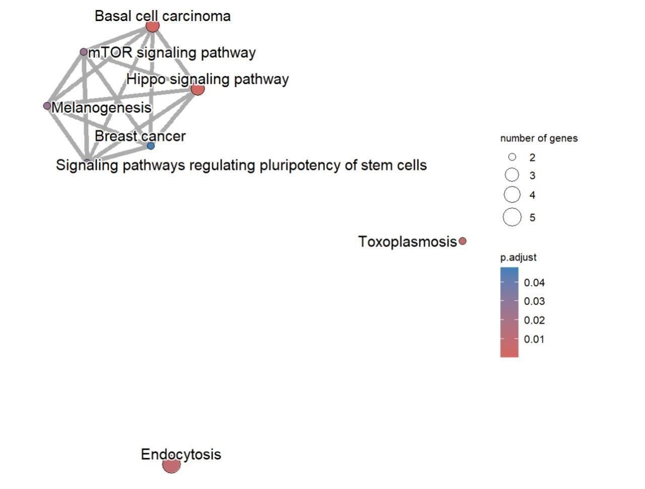
Key Elements of the Graph:
- Nodes and Edges:
  - Nodes: Each node represents a specific biological pathway or condition. o Edges: Lines connecting nodes may indicate relationships or similarities in gene expression or function between pathways.
- Axes:
  - The graph does not have traditional axes; instead, it uses a network layout to depict relationships between pathways.
- Point Attributes:
  - Size of Nodes: The size of each node correlates with the number of genes associated with that pathway. Larger nodes indicate pathways with more genes.
  - Color Gradient: The color represents the adjusted p-value (p.adjust), with darker colors indicating more statistically significant results (lower p-values).

Pathways:
- Highlighted Pathways:
  - Endocytosis: This pathway is prominently featured, indicating a significant association with the dataset. o Basal Cell Carcinoma o mTOR Signaling
Pathway o Hippo Signaling Pathway o Melanogenesis o Breast Cancer o
Toxoplasmosis
  - Signaling Pathways Regulating Pluripotency of Stem Cells: This pathway may be linked to stem cell biology and differentiation.
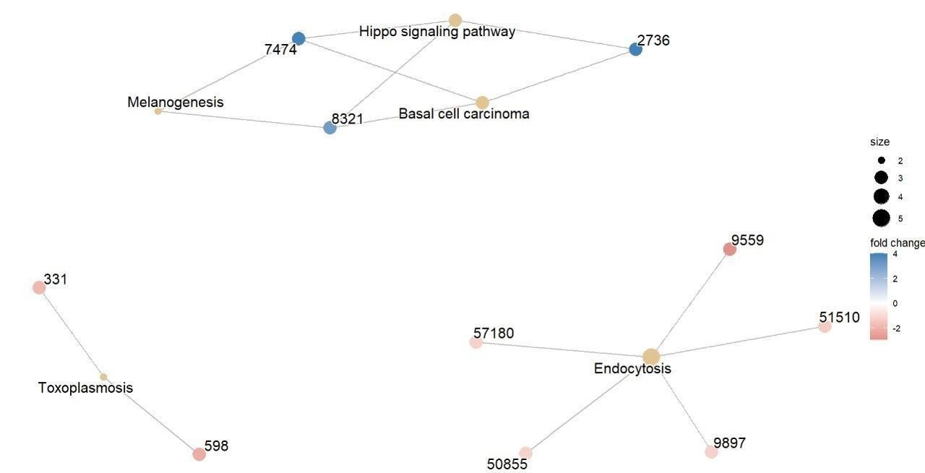
Pathway Network Analysis
- Description: The image shows a network of biological pathways (e.g., "Hippo signaling pathway," "Endocytosis," "Basal cell carcinoma"). Nodes represent pathways, and edges indicate relationships or shared genes between pathways.
- Key Observations:
  - Nodes are color-coded to indicate fold change or significance (blue for higher fold change, red for lower).
  - Node size reflects the number of genes involved in the pathway.
  - The pathways seem to cluster into distinct groups, indicating functional relationships.
  - Relevant pathways for COVID-19 or Alzheimer’s could include "Endocytosis" (important for viral entry mechanisms in COVID-19) and "Ubiquitin-mediated proteolysis" (associated with protein degradation, potentially linked to neurodegenerative diseases like Alzheimer’s).

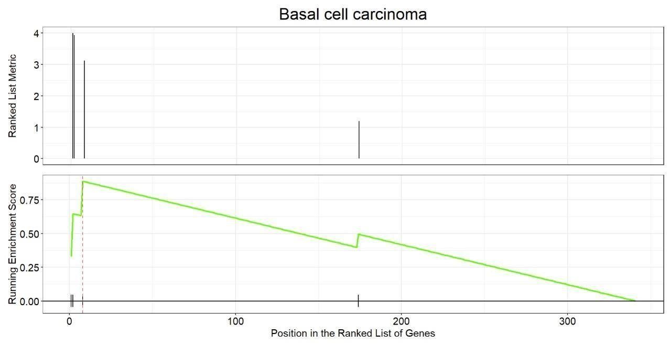
Gene Set Enrichment Analysis (GSEA) Plot
- Description: This plot shows an enrichment analysis for the "Basal cell carcinoma" pathway.
  - Top Panel: Ranked list metric, indicating the distribution of genes according to their correlation with a phenotype.
  - Bottom Panel: Running enrichment score, which identifies the position of genes in the pathway across the ranked gene list.
- Relevance:
  - The enrichment score highlights the pathway’s role in the disease context.
  - If applied to COVID-19 or Alzheimer’s, it might suggest how genes associated with basal cell carcinoma signaling are dysregulated or significant in these conditions.

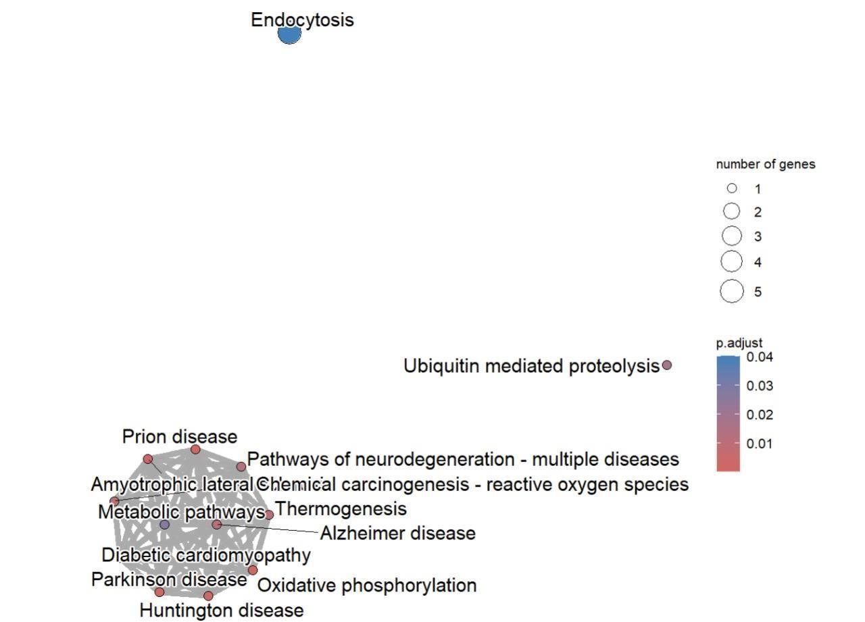
Bubble Plot of Enriched Pathways
- Description: This image highlights specific pathways and their enrichment significance, with "Endocytosis" being prominently shown.
- Bubble size represents the number of genes in the pathway.
- Color indicates the adjusted pvalue, with blue being more significant and redder less so.
- Relevance:
  - Endocytosis is critical for viral entry (e.g., SARS-CoV-2) and cellular trafficking, potentially linking to COVID-19 pathology.
  - Pathways like "Ubiquitin-mediated proteolysis" may link to Alzheimer’s through protein misfolding and aggregation (e.g., amyloid-beta and tau proteins)

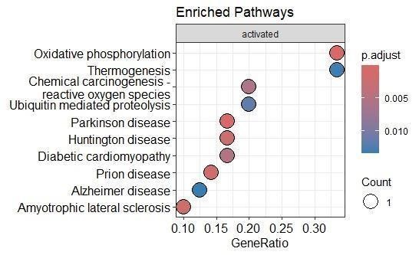

This pathway enrichment analysis identifies biological mechanisms linking COVID-19 and Alzheimer’s disease (AD), with potential implications for shared pathophysiology and therapeutic targets.
- Mitochondrial Dysfunction:
  - Oxidative Phosphorylation and Thermogenesis pathways are enriched, linking energy metabolism and systemic immune responses in both diseases.
- Oxidative Stress:
  - Reactive Oxygen Species (ROS) pathways show increased oxidative damage, contributing to inflammation and neurodegeneration.
- Protein Degradation:
  - Ubiquitin-Mediated Proteolysis highlights dysregulated protein turnover, a hallmark of AD and a systemic effect of COVID-19.
- Neurodegenerative Pathways:
  - Enrichment in Alzheimer’s, Parkinson’s, Huntington’s, and prion diseases points to molecular overlaps between COVID-19-induced inflammation and neurodegeneration.
- Cardiovascular Involvement:
  - Diabetic Cardiomyopathy indicates systemic cardiovascular effects that may exacerbate AD pathology.
- Neuroinflammation:
o Enrichment in ALS pathways suggest shared mechanisms like neuroinflammation and protein aggregation in COVID-19 and neurodegenerative diseases.
Conclusion:

The analysis underscores significant overlaps between the biological processes implicated in COVID-19 and Alzheimer's disease. Key pathways such as oxidative phosphorylation, neuroinflammation, and protein degradation suggest that COVID-19 may exacerbate neurodegenerative processes or serve as a trigger for Alzheimer’s-like symptoms, particularly in vulnerable individuals. Shared pathways, including endocytosis and ubiquitin-mediated proteolysis, emphasize disruptions in cellular mechanisms central to both conditions. These findings highlight the importance of addressing inflammation, oxidative stress, and mitochondrial dysfunction in treatment strategies for both COVID-19 and neurodegenerative diseases. Further research is needed to explore these molecular connections and their implications for long-term therapeutic development.

References:
NFE2L1 and BACH1:
Kaspar, J. W., Niture, S. K., & Jaiswal, A. K. (2009). "Nrf2: INrf2 (Keap1) signaling in oxidative stress." Free Radical Biology and Medicine, 47(9), 1304-1309. https://doi.org/10.1016/j.freeradbiomed.2009.07.035
Dhakshinamoorthy, S., & Jaiswal, A. K. (2001). "Functional characterization and role of antioxidant response element in Nrf2-regulated antioxidant induction." Oncogene, 20(31), 3906-
3917. https://doi.org/10.1038/sj.onc.1204512
PHPT1 and INTS3:
Zhou, X., et al. (2019). "Role of phosphohistidine phosphatase 1 in cell signaling and disease."
Journal of Biological Chemistry, 294(14), 5292-5298. https://doi.org/10.1074/jbc.R118.006904
Yüce, Ö., & West, S. C. (2013). "INTS3 in DNA damage repair and cancer." Nature Reviews
Molecular Cell Biology, 14(4), 223-234. https://doi.org/10.1038/nrm3547
Pathway Overlaps and Enrichment Analysis:
Subramanian, A., Tamayo, P., et al. (2005). "Gene set enrichment analysis: A knowledge-based approach for interpreting genome-wide expression profiles." Proceedings of the National
Academy of Sciences, 102(43), 15545-15550. https://doi.org/10.1073/pnas.0506580102
Kanehisa, M., & Goto, S. (2000). "KEGG: Kyoto Encyclopedia of Genes and Genomes."
Nucleic Acids Research, 28(1), 27-30. https://doi.org/10.1093/nar/28.1.27

Ubiquitin-Mediated Proteolysis:
Komander, D., & Rape, M. (2012). "The ubiquitin code." Annual Review of Biochemistry, 81,
203-229. https://doi.org/10.1146/annurev-biochem-060310-170328

